Biological & Ecological Engineering (BEE) Department
Colleges of Engineering and
Agricultural Science
bee.oregonstate.edu

Ecological Engineering
Undergraduate Advising Guide
2022-2023

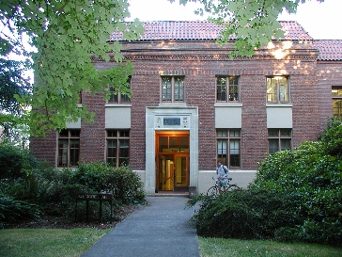
Registration Dates

FALL TERM 2022
Priority registration runs Sunday, May 15, 2022 to Wednesday, June 1, 2022

WINTER TERM 2023
Priority registration runs Sunday, Nov 13, 2022
to Wednesday, Nov 30, 2022

Gilmore Hall
124 SW 26th Street
(located at intersection of
Campus Way and 26th St.)

SPRING TERM 2023
Priority registration runs Sunday, Feb 26, 2023 to
Wednesday, March 15, 2023

https://bee.oregonstate.edu/biological-and-ecological-engineering/advisors

PREFACE

This advising guide is intended to give an overview of the requirements for the B.S. Ecological Engineering (EcoE) degree in the Biological & Ecological Engineering (BEE) department at Oregon State University (OSU). This major requires 180 credits for graduation and generally takes 4 years to complete.

This guide includes information about course prerequisites and sample term-by-term plans to graduate within 4 years. To create an individualized curriculum plan, log in to MyDegrees and utilize the Planner. The use of Planner is required for all College of Engineering students.

The information presented in this guide supplements information found in the OSU General Catalog as well as in the OSU Registration Information Handbook. It is the student's responsibility to be familiar with important dates, deadlines, regulations and rules detailed within these documents. Please also carefully review the College of Engineering and the BEE Department policies for admission, student performance, and academic requirements.

Important Links:
- OSU General Catalog: http://catalog.oregonstate.edu/
- OSU Registration Information Handbook: https://registrar.oregonstate.edu/how-register-registration-information-handbook
- OSU Office of the Registrar webpage: https://registrar.oregonstate.edu/
- College of Engineering webpage: https://engineering.oregonstate.edu/
- Biological & Ecological Engineering webpage: https://bee.oregonstate.edu/

Campus Resources:
- Academic Success Center (ASC): https://success.oregonstate.edu/
- Admissions Office: https://admissions.oregonstate.edu/
- Counseling & Psychological Services (CAPS): https://counseling.oregonstate.edu/
- Degree Partnership Program (DPP): https://partnerships.oregonstate.edu/
- Disability Access Services (DAS): https://ds.oregonstate.edu/
- Diversity & Cultural Engagement: https://dce.oregonstate.edu/
- Financial Aid: https://financialaid.oregonstate.edu/financial-aid
- Human Services Resource Center: https://studentlife.oregonstate.edu/hsrc
- Scholarship Office: https://scholarships.oregonstate.edu/
- Student Care: https://studentlife.oregonstate.edu/student-care

DEFINITION OF ECOLOGICAL ENGINEERING
The EcoE degree at OSU is a unique, ABET-accredited degree that is the first of its kind in the nation. Ecological Engineering blends engineering and science, and focuses on the design of sustainable systems (natural, urban, and agricultural) that are consistent with ecological principles and integrate human activities into the natural environment to the benefit of both. This discipline is rapidly developing as an important new area of engineering. Graduates from our program are creative and innovative problem-solvers, and have found employment in water resources, irrigation design & management, river engineering, ecological restoration, water treatment, bioremediation, ecosystem modeling, and related fields.

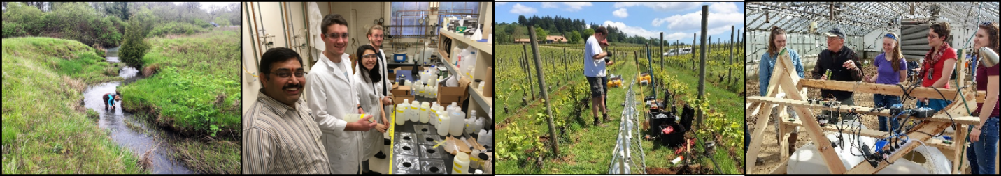

CURRICULUM OVERVIEW
Ecological Engineering depends on a broader mix of disciplines than other branches of engineering. In addition to the traditional engineering training in mathematics, physics, chemistry, and engineering principles, underclassmen EcoE students receive training in biology, ecology, soil science, geographic information systems (GIS), surveying, and environmental economics and policy. Upperclassmen complete upper-division engineering coursework that includes biosystems analysis and modeling, thermodynamics, fluid mechanics, hydrology and hydraulics, non-point source pollution, and bioremediation. Upper division engineering and science electives (minimum of 23 credits) as well as a two-quarter senior capstone course are also required. In addition, students take credits to meets basic OSU requirements under the Baccalaureate Core, which emphasizes critical thinking, writing, world cultures, appreciation of differences, the arts, sciences, literature, lifelong fitness, and global awareness. Graduation requires 180 credits.

See pages 4-8 for an example 4 year plan and a more detailed breakdown of the curriculum.

Example 4 Year Plan (180 credits required)
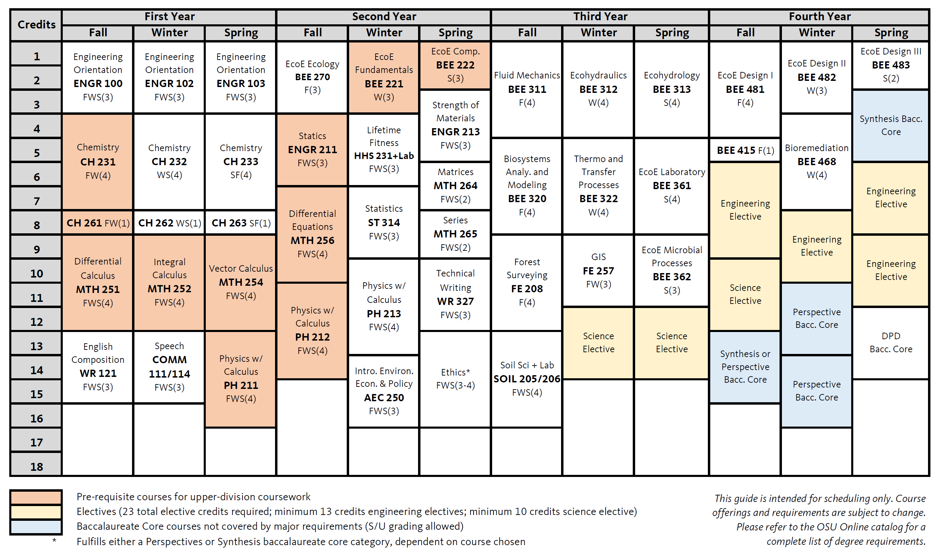
I. Required Courses (142 credits)

Math (23 credits)
Course # | Credits | Description | Prerequisites | Terms
MTH 251 | 4 | Differential Calculus | MTH 112 | FWS(Su)
MTH 252 | 4 | Integral Calculus | MTH 251 | FWS(Su)
MTH 254 | 4 | Vector Calculus | MTH 252 | FWS(Su)
MTH 256 | 4 | Differential Equations | MTH 254 | FWS(Su)
MTH 264 | 2 | Introduction to Matrix Algebra | MTH 252 | FWS(Su)
MTH 265 | 2 | Introduction to Series | MTH 252 | FWS(Su)
ST 314 | 3 | Statistics for Engineers | MTH 252 | FWS(Su)

Science (31 credits)
Course # | Credits | Description | Prerequisites | Terms
CH 231/261 | 5 | General Chemistry + Lab | MTH 111 | FW(Su)
CH 232/262 | 5 | General Chemistry + Lab | CH 231 | WS(Su)
CH 233/263 | 5 | General Chemistry + Lab | CH 232 | FS(Su)
PH 211 | 4 | General Physics with Calculus | MTH 252 (co) | FWS(Su)
PH 212 | 4 | General Physics with Calculus | PH 211, MTH 252 | FWS(Su)
PH 213 | 4 | General Physics with Calculus | PH 212, MTH 254 | FWS(Su)
SOIL 205/206 | 4 | Soil Science + Lab | N/A | FWS

Science and Public Policy (3-4 credits)
Course # | Credits | Description | Prerequisites | Terms
AEC 250 | 3 | Intro to Environ. Econ and Policy | MTH 111 | FWS(Su)
or ECON 201 | 4 | Intro to Microeconomics | MTH 111 | FWS(Su)

Ethics (3-4 credits)
Course # | Credits | Description | Prerequisites | Terms
IE 380 | 3 | The Responsible Engineer | Junior standing | WS
or PHL 205 | 4 | Ethics | N/A | FWS(Su)
or PHL 440 | 3 | Environmental Ethics | Sophomore standing | Su
Or PHL 443 | 3 | World Views and Environmental Ethics | Sophomore standing | FWS(Su)

Engineering (62 credits)
Course # | Credits | Description | Prerequisites | Terms
ENGR 100 | 3 | The Oregon State Engineering Student | N/A | FWS
ENGR 102 | 3 | Design Engineering and Problem Solving | N/A | FWS
ENGR 103 | 3 | Engineering Computation and Algorithmic Thinking | ENGR 102 + MTH 112 (co) | FWS
BEE 221 | 3 | EcoE Fundamentals | BI 211 + MTH 256 | W
BEE 222 | 2 | EcoE Computation | N/A | S
BEE 270 | 3 | EcoE Ecology | N/A | F
BEE 311 | 4 | Ecological Fluid Mechanics | PH 212 + MTH 254 + ENGR 211 | F
BEE 312 | 4 | Ecohydraulics | BEE 311 or CE 311 or CHE 331 | W
BEE 313 | 4 | Ecohydrology | BEE 312 | S
BEE 320 | 4 | Biosystems Analysis and Modeling | BEE 222 + MTH 256 | F
BEE 322 | 4 | Thermodynamics and Transfer Processes | BEE 320 | W
BEE 361 | 3 | EcoE Laboratory | BEE 312 | S
BEE 362 | 3 | EcoE Microbial Processes | BEE 222 | S
BEE 468 | 4 | Bioremediation | BEE 221 or ENVE 322 | W
BEE 481 | 4 | EcoE Design I (WIC) | BEE 322 | F
BEE 482 | 3 | EcoE Design II (WIC) | BEE 481 (in same AY) | W
BEE 483 | 2 | EcoE Design III (WIC) | BEE 482 (in same AY) | S
ENGR 211 | 3 | Statics | MTH 252 | FWS(Su)
ENGR 213 | 3 | Strength of Materials | ENGR 211 | FWS(Su)
Professional Skills (20 credits)
Course # | Credits | Description | Prerequisites | Terms
BEE 415 | 1 | Professional Development | BEE 469 (co) | F
COMM 111/114 | 3 | Public Speaking or Argument and Critical Discourse | N/A | FWS(Su)
HHS 231+PAC | 3 | Lifetime Fitness for Health and Physical Activity Courses | N/A | FWS(Su)
FE 257 | 3 | GIS and Forest Engineering Applications | N/A | W
FE 208 | 4 | Forest Surveying | MTH 252 | F
WR 121 | 3 | English Composition | N/A | FWS(Su)
WR 327 | 3 | Technical Writing | WR 121 | FWS(Su)

II. Elective Courses (23 credits minimum)
Students are required to take a minimum of 23 credits of upper division science and engineering electives (minimum 10 non-blanket hour* science elective credits and minimum 13 non-blanket hour* engineering elective credits). Pre-approved electives are listed in the Degree Checklist on MyDegrees and on the BEE advising webpage (link on bottom of Page 1). If a science or engineering course is not included on the pre-approved lists, students may submit a program petition form (found on the BEE advising webpage- link on bottom of Page 1) to the Head Academic Advisor to receive approval to count it as an elective. This petition will be reviewed by the undergraduate curriculum committee. A maximum of two 200-level engineering electives and one 200-level science elective may be taken.

*Blanket hour credits (BEE 401, 405, 410)
Blanket hour credits are taken by students completing undergraduate research (BEE 401), individualized study (BEE 405), or an internship (BEE 410). Just as with regular course credits, students are responsible for paying tuition for these credits. To receive blanket-hour credits, students must first submit a blanket-hour credit form to the Head Academic Advisor that is signed by their project supervisor and BEE faculty grader (if different person than project supervisor). They will then register for the credits and submit a substantial report to their supervisor and grader at the end of the term. More details on the requirements (as well as forms to be submitted) can be found here, https://agsci.oregonstate.edu/biological-and-ecological-engineering/blanket-hour-courses.

III. Baccalaureate Core (16 additional credits towards major)
OSU requires completion of a set of Baccalaureate Core ("Bacc Core") courses, divided into 4 groups‐ Skills, Perspectives, Synthesis, and Difference, Power, and Discrimination. Some of these categories are met by required courses within your major (*).

Skills (15 credits)
Course Category | Credits | Met by | S/U Allowed
Fitness* | -- | HHS 231 + PAC | Yes
Mathematics* | -- | MTH 251 | No
Speech* | -- | COMM 111 or 114 | No
Writing I* | -- | WR 121 | No
Writing II* | -- | WR 327 | No

Perspectives (24 credits)
Course Category | Credits | Met by | S/U Allowed
Biological Science w/ Lab* | -- | Soil Science | No
Cultural Diversity | 3 | N/A | Yes
Literature & Arts | 3 | N/A | Yes
Physical Science* | -- | Chemistry or Physics courses | No
Social Processes & Institutions* | -- | AEC 250 | No
Western Culture* | 3 | PHL 205 (if taken) | Yes (No if PHL 205)

Synthesis (6 credits)
Course Category | Credits | Met by | S/U Allowed
Contemporary Global Issues | 3 | PHL 440 or PHL 443 (if taken) | Yes (No if PHL 440 or PHL 443)
Science, Technology, and Society* | 3 | IE 380 (if taken) | Yes (No if IE 380)

Difference, Power, & Discrimination (3 credits)- No S/U grading

